 | IN THE DISTRICT COURT OF EL PASO COUNTY, TEXAS |  |  |  |  |  |  |  |  |  |  |  | JUDICIAL DISTRICT
 | 1st Degree Felony |  |  |  |  | Misdemeanor |  |  |  | STATE OF TEXAS
 | 2nd Degree Felony |  |  |  |  | Capital |  |  |  | VS. |  |  | CASE No.
 | 3rd Degree Felony |  |  |  |  | Death
 | State Jail Felony |  |  |  |  | Appeal |  |  |  |  |  |  | JIMS No.
 |  |  |  |  |  | Civil
 | ATTORNEY |  |  |  |  |  |  |  |  | FOR COUNTY AUDITOR'S OFFICE USE ONLY
 | ADDRESS |  |  |  |  |  |  |  |  | Atty Fee Number |  |  |  | Date Entered
 |  |  |  |  |  |  |  |  |  | Vendor Number
 |  |  |  |  |  |  |  |  |  | Trans Code: |  | 200
This case is set for: |  |  |  |  |  |  |  |  |  | Index & Sub-Obj: |  | COUNCIL-6856
at |  |  | m. in |  |  |  |  | Court.
 |  |  |  |  |  | CLAIM FOR SERVICES OR EXPENSES
 |  |  | Service IN Court |  |  |  |  |  |  | Date |  | Hours/Tenths | This area for Auditor use only
A. Arraignment
B. Bond / Bail
C. Examining Trial
D. Habeas Corpus
E. Judge's Conference
F. Pre-trial Motions
G. Trial/Plea
H. New Trial Motions
I. Revocation
J. Other
 |  |  |  |  |  |  |  |  |  |  |  |  | Total Time: 0
 | Multiply total in court time by $90.00 per hour, |  |  |  |  |  |  |  |  | Total IN Court Claim: $0.00
 | Service OUT of Court |  |  |  |  |  |  |  |  | Date |  | Hours/Tenths | This area for Auditor use only
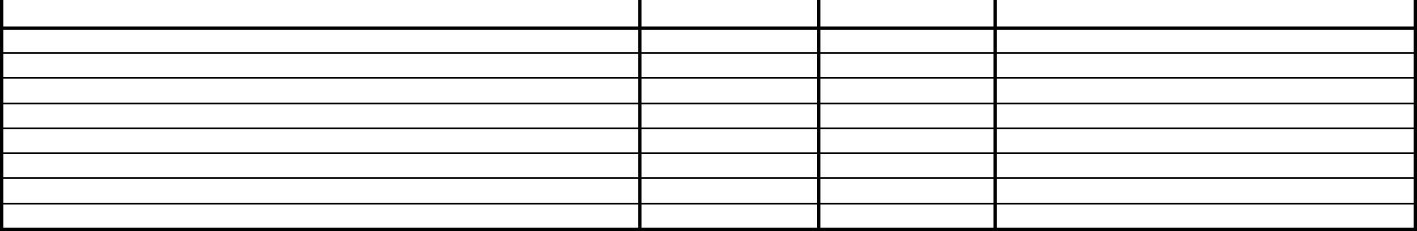
- Interviews and Conferences

- Obtaining and reviewing records

- Legal research and writing

- Other

 |  |  |  |  |  |  |  |  | Total Time: 0
 |  | Multiply total out of court time by $75.00 per hour, |  |  |  |  | Total OUT of Court Claim: $0.00
 |  |  |  |  |  | COURT APPROVED REIMBURSABLE EXPENSES
O. Long distance telephone service |  |  |  |  |  |  |  |  | ** NOTE **
P. Copies |  |  |  |  |  |  |  | All receipts for reimbursable items R,S, and T must be
Q. Photographs |  |  |  |  |  |  |  | attached.
R. Witness fee ** |  |  |  |  |  |  |  | Total Expenses: $0.00
S. Travel **
T. Mileage to / from Jail Annex .40 cents a mile ** |  |  |  |  |  |  |  | Total Claim: $0.00
 |  | ATTORNEY CERTIFICATION |  |  |  |  |  | ORDER APPROVING PAYMENT
I swear and affirm the truth and correctness of the above |  |  |  |  |  |  | The above voucher is approved to the amount of
statement. |  | I CERTIFY THAT I HAVE NOT SUBMITTED ANY
OTHER VOUCHER ON THIS CASE OR; I CERTIFY I HAVE
FILED A VOUCHER FOR
ON |  | , 20 |  |  |  |  | JUDGE: ______________________________ |  |  |  |  | DATE: ____________
 |  |  |  |  |  |  |  | Excess payment approval
 | Attorney Signature
 | State Bar No. |  |  |  |  |  | JUDGE: ______________________________ |  |  |  |  | DATE: ____________
Date of Appointment
 |  | E-mail ____________________________________
I further certify that no other funds from any other source have been received as payment on this case.

I further certify that any other funds received from any other source in payment on this case are fully disclosed and attached.

COUNCIL OF JUDGES ADMINISTRATION |  |  | ATTORNEY REQUIREMENTS-PROCESS FOR PAYMENT
 | Date Received: __________________ | (1) Original to Court for signature, (2) Original and 1 copy to the Council of Judges Administration, (3) Council of
 |  | Judges Administration signs off on voucher and retains a copy to be forwarded to the District Clerk, (4) After
 | Received by: ____________________ | process is completed, attorney can leave original voucher with the Council of Judges to forward to Auditors
 |  | office or attorney can hand carry voucher to Auditors office for payment.

Voucher for services on criminal cases must be submitted within 45 days after final court appearance. Failure to comply will result in forfeiture of fee.

THE COURT APPROVES PAYMENT OF A VOUCHER ON CONDITION UPON DEFENDANT'S COUNSEL HAVING FILED A CURRENT SENATE BlLL 7 AFFIDAVIT WITH THE COUNCIL OF JUDGES ADMINISTRATION.

EFFECTIVE FOR APPOINTMENTS MADE AFTER SEPTEMBER 1, 2014.

