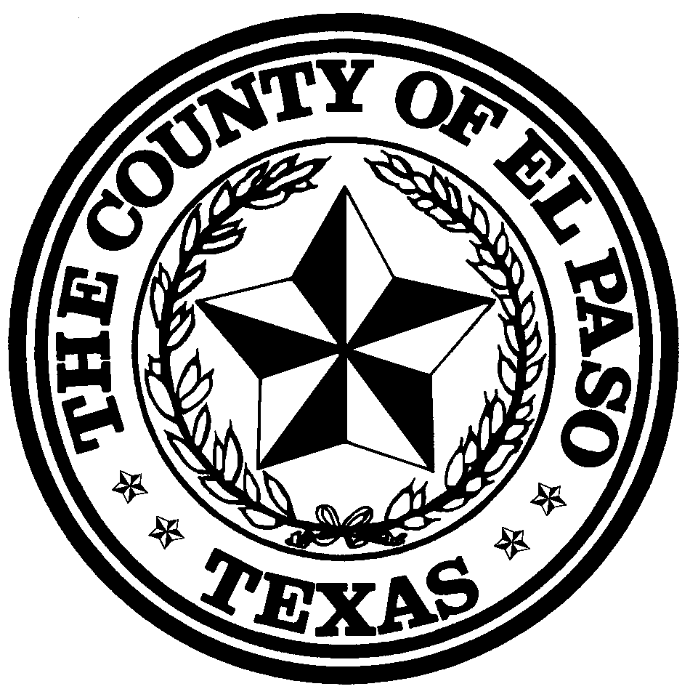

County of El Paso Purchasing Department

800 E. Overland Room 300

El Paso, Texas 79901
(915) 546-2048 / Fax: (915) 546-8180

www.epcounty.com

ADDENDUM 2

To: All Interested Vendors

From: Araceli Hernandez, Formal Bid/ Buyer

Date: May 31, 2018

Subject: RFP #18-030, Third Party Administrator for Health and Dental Benefits for the County Of El Paso

- The Opening Date has been extended to Thursday, June 21, 2018 at 2:00 p.m.

- Deadline to questions has not been extended.

